A Guide for Alcohol Importers and Exporters in the UK
oliver7520
Oct 8, 2025
3 min read

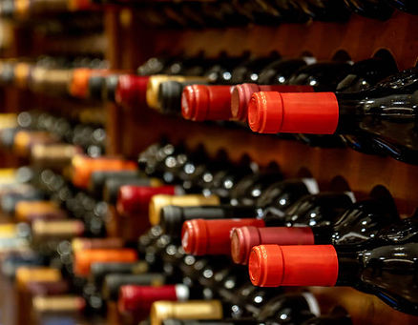
The UK alcohol market is experiencing significant growth and transformation, driven by changing consumer preferences. Recent statistics reveal that the UK drinks industry has seen a notable increase in demand, especially in premium and craft products, which now constitute a sizable share of the market. This shift towards premiumisation reflects a broader trend among consumers seeking higher-quality, distinctive beverages, which in turn influences supply chains and import/export activities. Emerging markets like India, especially its booming whisky sector, present lucrative opportunities for UK exporters. Trade agreements and tariffs tailored to promote premium UK products can make UK offerings more competitive, helping leverage India’s growing middle class and shifting consumer preferences toward premium, imported spirits. Strategic trade initiatives are thus vital to capitalise on these expanding opportunities in the global alcohol landscape, particularly as premiumisation continues to dominate consumer preferences.

Key Steps in the Import Process - Registration and Licensing
Importers must be registered with HMRC and may need specific licences, especially if importing alcohol in duty suspension or producing alcohol for commercial sale. For instance, from February 1, 2025, producers can apply for an Alcoholic Products Producer Approval (APPA), which permits the import and storage of duty-suspended alcohol. Any producer of alcoholic beverages (including spirits, wine, beer, cider, and other fermented products) must register and obtain the APPA from HMRC. This approval replaces previous excise registrations and licences related to alcohol production and allows producers to handle imports and exports legally.

Key Steps in the Export Process – Registration and Licensing
Export procedures mirror import processes but require additional certifications, such as export licences and specific labelling for international markets. Spirits like whisky must meet destination country requirements, and export documentation must certify compliance with both UK and foreign standards. Additionally, all movements of duty-suspended alcoholic products from an approved premises to export must be recorded and tracked using HMRC’s EMCS system. This ensures that duty suspension rules are properly observed during transport prior to the goods leaving the UK.

Preparing Documents and Compliance Checks
Relevant documentation is vital. An accurate commercial invoice detailing the nature, quantity, and value of the product must accompany shipments. For wine imports, although the UK has relaxed some requirements in respect of the VI-1 certificates (previously used to demonstrate compliance with EU wine production standards), it is still advisable to understand the obligations, especially for goods entering Northern Ireland where EU rules apply under the Northern Ireland Protocol. Certificates of origin and certificates of analysis might also be necessary, depending on product type and origin.

Customs Clearance and Duty Payment
Upon arrival, customs officials inspect the shipment, assess duties based on product type, alcohol strength, and origin, and process VAT payments. Effective customs clearance can be facilitated by a knowledgeable customs broker who ensures documentation accuracy, reduces delays, and manages duty payments efficiently. Excise duty on alcoholic beverages remains one of the key financial considerations. Calculations are typically based on alcohol strength and volume. Duty payments can be made upfront upon import or deferred under specific duty suspension arrangements if the goods are stored in licensed warehouses or approved premises. VAT is assessed on the total cost, including the value of goods, excise duty, and customs duty. Proper invoicing and record-keeping are crucial to accurately calculate and remit VAT.

Labelling Compliance
Proper labelling is essential to meet UK law and consumer protection standards. Labels must include the importer’s or responsible person’s UK address, ingredient lists, allergen declarations, net volume, and alcoholic strength. Non-compliance can lead to delays or rejections at customs and damage to brand reputation. There are several alcohol labelling specialists and industry regulators that offer free support and advice.

Record Keeping and Compliance Audits
It is specifically stated under excise and customs rules that records showing imports and exports of alcoholic products must be maintained and made available for up to six years to comply with legal requirements. These records support audits and compliance checks, ensuring that duties and taxes have been appropriately reported and paid. Digital record-keeping aligned with HMRC’s requirements enhances transparency and eases possible inspections.

How Customs Wise Can Help
Customs Wise streamlines the import/export process-handling documentation, customs declarations, duty calculations, and compliance checks. This not only saves time and costs but also mitigates risks associated with non-compliance or incorrect documentation. For small businesses, a customs broker can be vital in navigating complex procedures, especially when dealing with international shipments or new markets.
Whether importing or exporting alcohol, working with an experienced customs broker can ensure that the process remains smooth, compliant, and cost-effective. At Customs Wise, we have a background in supporting alcohol traders with customs compliance, specifically in the wine industry.

